Problem to be solved
Reducing Power Shortage Through Alternative Energy
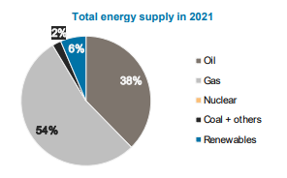
Non-renewable energy sources, being the backbone of Egypt’s industrial sector, is an expensive, inefficient and limited source of energy. 94% of Egypt’s energy supply is considered to be non-renewable (as of 2021), with gas at 54% and oil at 38% as shown in figure 1.
Figure 1 Egypt's total energy supply in 2021

With 1 066 747 (TJ) imports and 871586 (TJ) exports, Egypt has a net energy trade of -195161 (TJ), which increases energy costs in Egypt, increasing the prices on Egyptian consumers and reducing the net amount of distributed energy due to the cost of importing or production of energy.

The heavy load on the economy due to the increasing energy requirements is also due to the prices of imported non-renewable resources like oil which has an average price of $76.48/bbl. and natural gas which has an average price of $5.75/MMBtu.
which increases pressure on the national income. Furthermore, this energy storage leads to unfair distribution of electricity across cities, this can be seen in Nouba, South Sinai, which is located among tourist hotels, villages and restaurants that get the majority of electricity and most infrastructure maintenance.

The power shortage issue in Nouba is caused by several factors which are: Low-quality electricity infrastructure, High prices of non-renewable energy and Bad utilization of renewable energy.

Positive Consequences
1-Lower Oil Prices
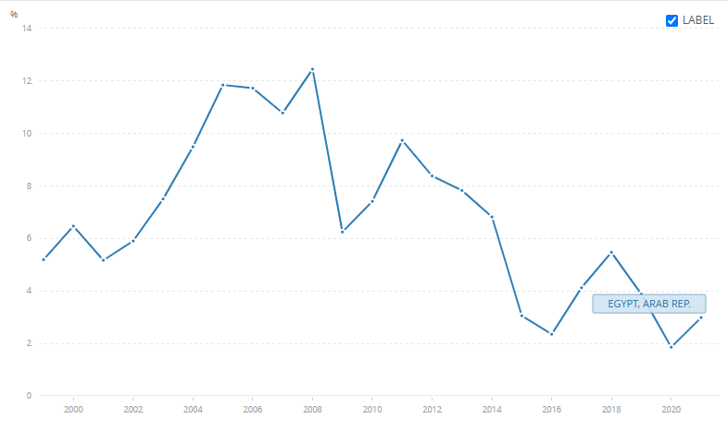
Egypt has a power score of 1.82, which puts it at rank 65 in the Emerging Markets power ranking. In comparison to 2023, Egypt has dropped in the power rankings by 25 places, from rank 40, to rank 6. This drop in ranks is due to dependance on non-renewable sources such as fossil fuels which price increase rapidly, for example Oil rents are the difference between the value of crude oil production and the costs of producing it. Oil rent has increased to 3 in Egypt in 2021 which is shown in figure 2.

The high demand for fossil fuels such as oil and natural gas combined with the low supply of said fossil fuel has increased the prices of fossil fuels, thus increasing the load on Industry and Military sectors which require large amounts of fossil fuels.
Figure 2 oil rent in Egypt

Utilizing renewable energy resources such as wind energy, solar energy and hydropower would decrease the residential demand for fossil fuels, largely decreasing the demand for fossil fuels thus decreasing the fossil fuel price for all public sectors.

2-Reduced Electricity Prices
The current dependance on non-renewable energy sources in Egypt like oil and natural gas has caused electricity prices to increase, for example reports announced in January 2024 have shown an increase ranging between 10 and 40 per cent for different brackets, with the highest shouldering the largest hike in only Q1 2024.

The rate for the first bracket, covering consumers of between 0 and 50 kWh, has increased from LE0.58 to LE0.68 per kWh.
The second tier, covering consumption from 51 to 100 kWh, is now LE0.78 per kWh, up from LE0.68. For the third bracket, when consumption exceeds 100 kWh and reaches up to 200 kWh, the rate has risen from LE0.83 to LE0.95.
consumption surpassing 200 kWh falls into the fourth bracket, which goes up to 350 kWh, with an increase from LE1.25 to LE1.55 per kWh. This pattern of price increase also continues on higher consumption according to the report.

Utilizing renewable energy, such as wind energy, can solve such problems through increasing the local production of electricity, which would lead Egypt to have a power surplus instead of a deficit.

3-Less Pollution
Fossil fuel power generators are major pollutants to the air. The air Contains three major pollutants that are harmful to the environment which are: carbon monoxide, nitrogen dioxide, and carbon dioxide. Fossil fuel plants and industrial sectors are the main producers of said gases. Furthermore, car emissions contribute to 33% of the air pollution In Egypt, this is because electric vehicles only make up 0.1% of car sales, therefore 99.9% of cars in Egypt depend on fossil fuels, which not only increases air pollution but also increases oil prices.
As a result, Egypt is in 12th position in the global pollution index and 9th in air pollution. Expanding use of renewable energy sources would decrease the air pollution through reducing the importance of fossil fuel power generators and later fully replacing fossil fuels thus reducing pollution while also reducing demand for fossil fuels.
Negative Consequences
1-Limited Industrial Capacity
Due to the high prices of fossil fuels, for example natural gas that has reached $5.75 per million British thermal units, combined with the price of moving such fuels across large areas of land to locations such as South Sinai, the cost of implementing industrial improvements in such areas is costly, and often ignored despite the possibilities of said locations in areas of rock mining or other industrial sectors.
2-Unfair Infrastructure Distribution
Fossil fuels require large power generators usually around the center of the country or outskirts of central cities, then these generators require large infrastructure both underground and above the ground to be transported to cities. The high cost of the required infrastructure can limit the reach of fossil fuel-generated electricity to certain main locations in Egypt.
As a result, electricity reach in far locations such as South Sinai is limited, damaging the economy and social life.
3-Economic Loss
Egypt also has a large water supply through the Nile with an annual share of around 55 m3 billion. However, the water supply, fertile soil of 2.3 million ha and industrial opportunities such as mineral extraction, building material extraction, food industries and manufactures are not utilized to the fullest extent. This is because the energy required to fully exploit such resources is too expensive, making the process unprofitable. Which reduces job opportunities and local income, ultimately causing economic loss in the country.

